Task 1: File copy using open(), read(), write(), lseek() and close()
Code:
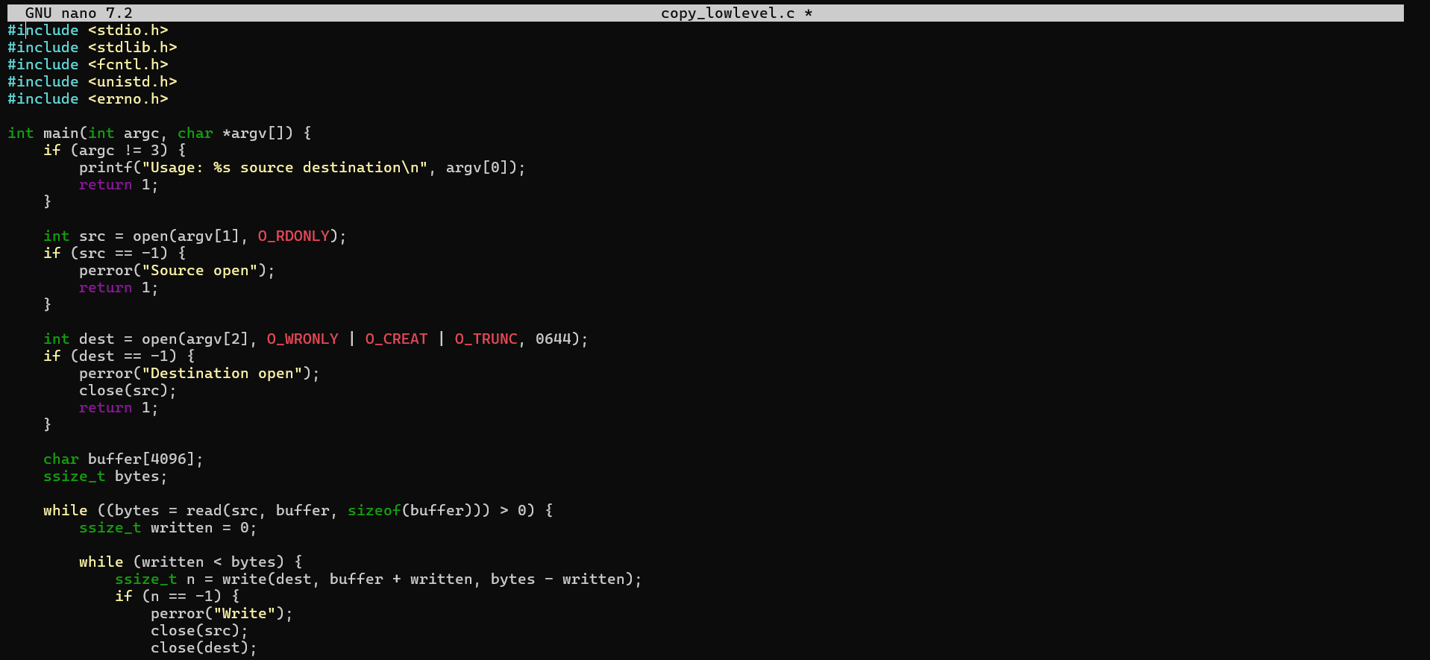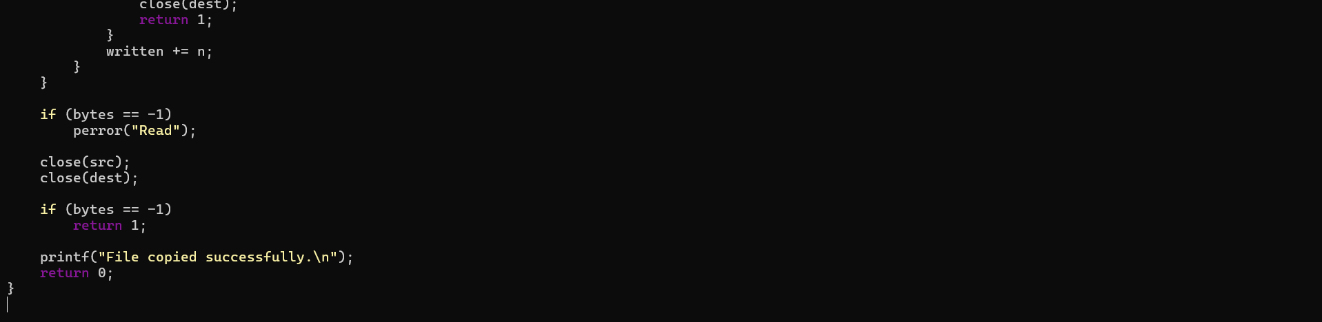

Output:
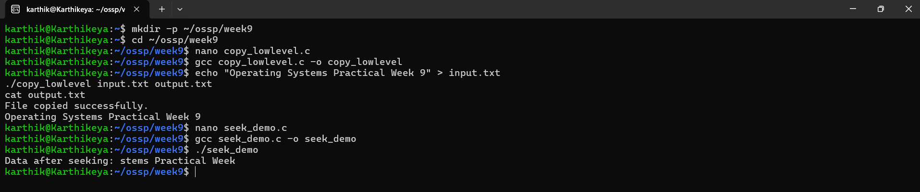

Task 2: Compare system calls with standard library file I/O
Code:
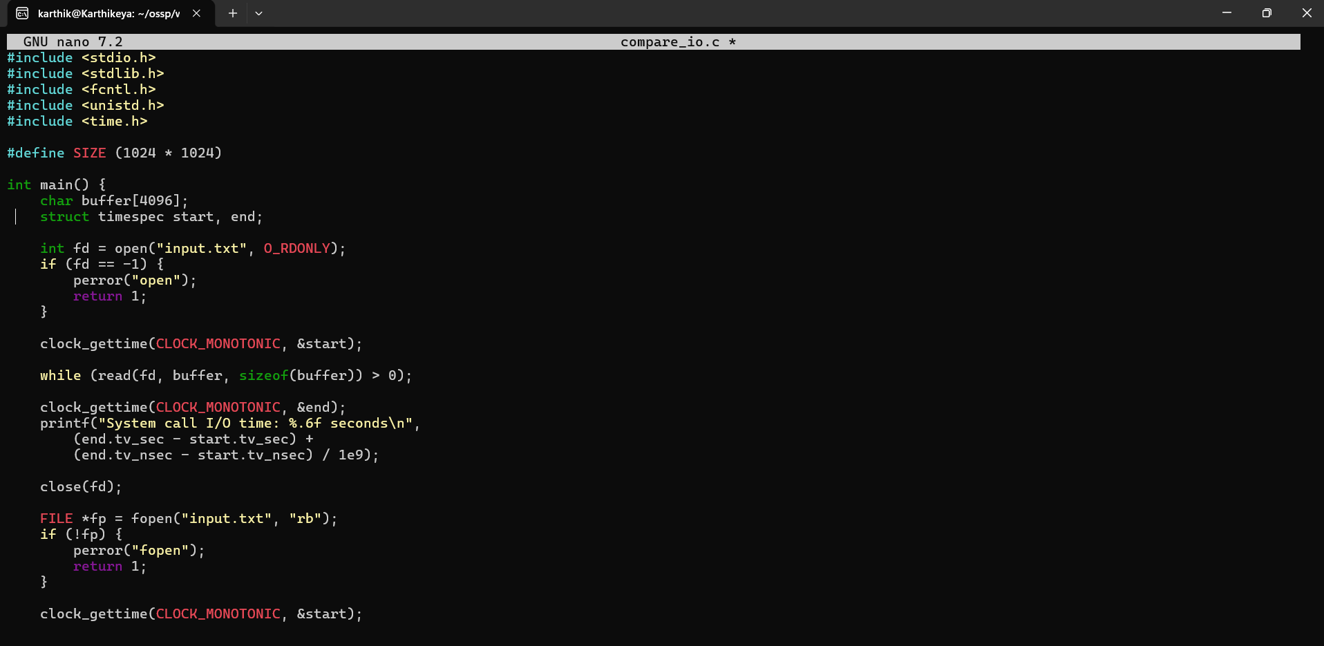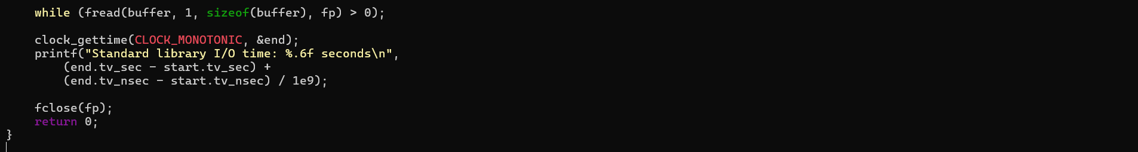

Output:

